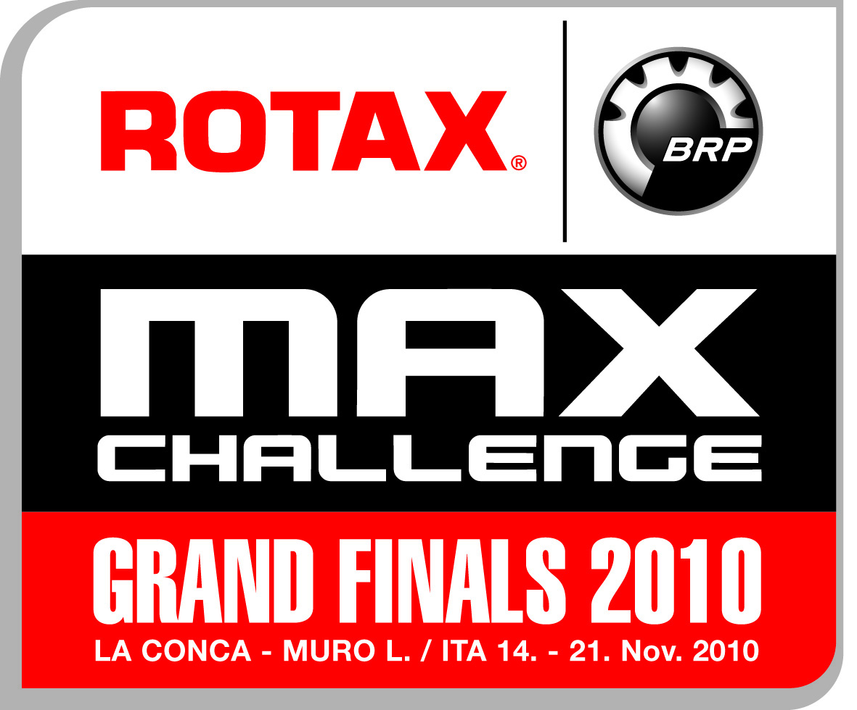
TO:
Commissione Sportiva Automobilistica Italiana
A.C.I.-C.S.A.I.
Via Solferino 32
00185 ROMA, ITALY

Tel : +39 0644 51 627 (FIK)
Fax : +39 0644 61 465 (FIK)
Internet : www.fik.it
E-mail : claudio.bacchetta@fik.it

STARTING PERMISSION / VISA
ROTAX MAX GRAND FINALS in LA CONCA / ITA

This is to certify that Mr/Ms.

First name | Surname | Country

holds a valid, current international karting competition and entrant license

(Competition licence number )
(Entrant licence number )

This federation hereby authorises the above-mentioned competitor to take
part in the ROTAX Max Challenge Grand Finals from 18.11.2010 – 21.11.2010 in La Conca-Muro Leccese / Italy.

Signature ASN representative: ……………………

Name of ASN representative:

Position of ASN representative:

PLS. ENSURE FORM IS STAMPED AND SIGNED BY NATIONAL ASN (KARTING FEDERATION)

