



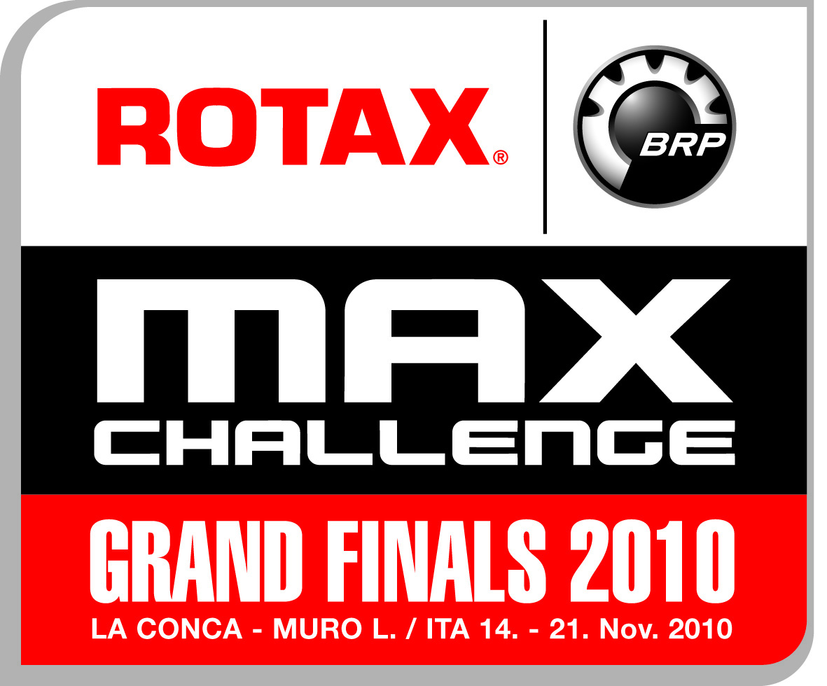
ROTAX MAX GRAND FINALS
at La Conca / Muro Leccese / ITA (18.-21.11.2010)

 |  |  |  |  |  |  |  |  | JUN /  SEN | DD2
 | FOR OFFICIAL USE ONLY
 | Indemnity Signed |  | YES / NO |  | Entrant License | YES / NO |  |  | KART NO:
 | Biodata Form |  | YES / NO |  | Competition License | YES / NO
 | Scrutineering |  | YES / NO |  | License Number
 | Passport |  | YES / NO

ENTRY FORM

Name of Entrant
Entrant License Number
Address
Tel No. |  | Fax No.
E-Mail

Name of Driver |  |  | Date of Birth
Address
Tel No. |  | Fax No.
Passport / I.C. No.
License No
Name of Pit Crew | 1) |  |  |  | Age :
 | 2) |  |  |  | Age:

Entries will not be considered unless accompanied by a photocopy of competition license an
entrants’ license, if applicable.

